Note: Include this page only when adding / amending / deleting a document. If using this document as a record, this Revision History page can be omitted.

REVISION HISTORY

Revision no | Date | Description of Changes | Reason for Revision | Revised by | Approved by
2 | 01 June 13 | Add revision history page | - Recommendation from Stage 2 audit | RDPlacido
3 | 01 May 14 | Removed Incident Summary Report in the references | - Updated references | LDLacuna
4 | 8 Apr 16 | Added disclaimer when printing the document | For document control | RCGanal | MVBergantin
TM-BR-MG- 11 Rev02, 10302015

I. Objective
To ensure good and harmonious working relationship between the employees and employer by providing interventions that will promote communication, work-life balance, sense of belonging, and teamwork among employees, enforce the policies and actualize the consequences of infraction and address and settle any employee issue accordingly.
II. Scope
The scope of this procedure is the providing of social activities, resolving the grievance and conflict arose from the employment and enforcing the HR policy focusing merely on imposing the appropriate disciplinary action.
This procedure defines the action and responsibilities of the Payroll Specialist, HR Associate, HR Head and ManCom in providing various interventions to submission of report.
III. Definition of Terms
SurveyMonkey | - Is a website where survey forms are created. One can easily design a survey form and the site can collect and analyze the responses.
Intervention | - Activities that are aimed at improving individual and organizational health and effectiveness.  - Activities that will promote open and clear communication, camaraderie, actualize consequences and achieve compliance, address and clarify the vision, mission, responsibilities and expectations.

IV. Procedure Details
RESPONSIBLE | ACTIVITY | INTERFACE
HR Associate / HR Head  HR Head | 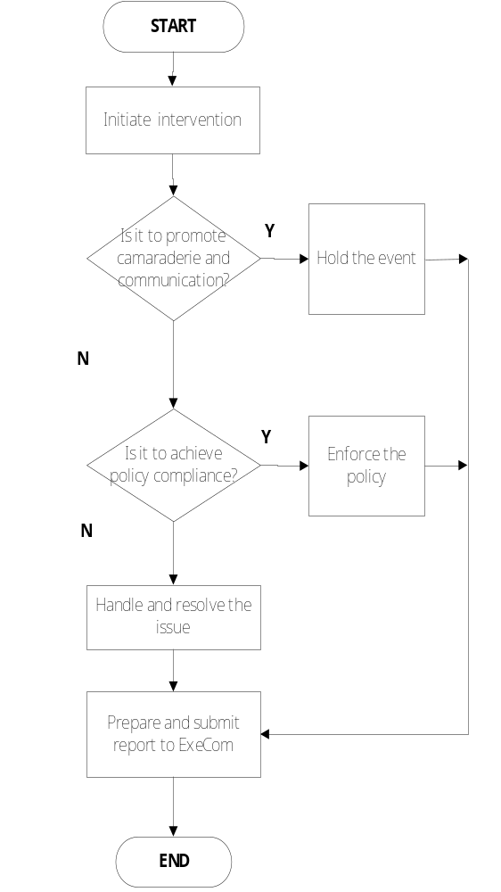 | ExeCom  Guidelines for the Provision of Social Activities  Guidelines for Policy Compliance Monitoring and Implementation  Guidelines for Grievance and Conflict Resolution  ExeCom / ManCom Events Satisfaction Report  Employee Visit Report  Post Event Report  Incident Report  Summary of Disciplinary Actions DA Summary Tracker

- References
- Table of Disciplinary Actions
- Disciplinary Action Slip
- DA History Card
- SurveyMonkey Event Satisfaction Survey
- Guidelines for the Provision of Social Activities
- Guidelines for Policy Compliance Monitoring and Implementation
- Guidelines for Grievance and Conflict Resolution

VI. Quality Records
- Events Satisfaction Report
- Post Event Report
- Incident Report
- Summary of Disciplinary Actions
- Disciplinary Actions Summary Tracker
- Employee Visit Report
- Memorandum

